**Assignment 2**

**Flow Chart:**

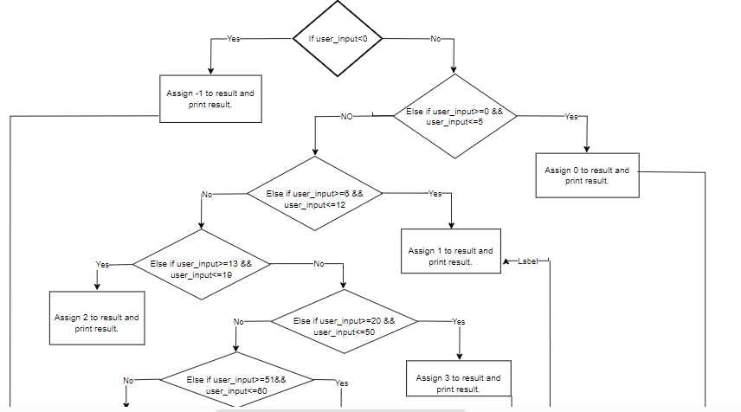

**Algorithms:**

1. Start.
2. Declare two identifiers user_input and result.
3. Now read the value from the user.
4. The value provided by the user has to be store in user_input.
5. If the value provided by the user is less the zero

assign /print value to result -1.

1. Else if value provided by the user is between zero to five assign/print value to result 0.
2. Else if value provided by the user is between six to twelve assign/print value to result 1.
3. Else if value provided by the user is between thirteen to nineteen assign/print value to result 2.
4. Else if value provided by the user is between twenty to fifty assign/print value to result 3.
5. Else if value provided by the user is between fifty- one to sixty assign/print value to result 4.
6. Else if value provided by the user is between sixty- one to one-zero-one assign/print value to result 5.
7. Else if value provided by the user is greater than one-hundred-one assign/print value to result -1.
8. Stop.